## Q1

|  |  |
| --- | --- |
| **Multiprocessing** | **Multiprogramming** |
| Multiprocessing refers to the processing of multiple processes at the same time by multiple CPUs. | Multiprogramming keeps several programs in main memory at the same time and execute them concurrently utilizing a single CPU. |
| It permits parallel processing. | Context switching takes place. |
| Less time is taken to process jobs. | More Time is taken to process the jobs. |
| It facilitates much efficient utilization of devices of the computer system. | Less efficient than multiprocessing. |
| Usually more expensive. | Such systems are less expensive. |

## Q2

1. User
2. Application Software
3. System Software
4. Shell
5. Kernel
6. Hardware

## Q3

1. Multithreading - Multithreading is the ability of a program or an operating system process to manage its use by multiple users at a time and to even manage multiple requests by the same user without having to have multiple copies of the programming running in the computer. Each user request for a program or system service (and here a user can be another program) is kept track of as a thread with a separate identity. As programs work on behalf of the initial request for that thread and are interrupted by other requests, the status of work on behalf of that thread is kept track of until the work is completed.
2. Multitasking – In an operating system, multitasking allows a user to perform more than one task (such as the operation of an application program) at a time. The operating system is able to keep track of where you are in these tasks and go from one to the other without losing information. Being able to do multitasking does not mean that an unlimited number of tasks can be juggled at the same time. Each task consumes system storage and other resources. As more tasks are started, the system may slow down or begin to run out of shared storage.
3. Kernel - The kernel is the heart of a computer operating system (OS). It is the core that provides the basic services for all other parts of the OS. It is the main layer between the OS and hardware, and it helps with process and memory management, file systems, device control and networking.
4. Spooling – It is a process in which data is temporarily held to be used and executed by a device, program or the system. Data is sent to and stored in memory or other volatile storage until the program or computer requests it for execution. "Spool" is technically an acronym for simultaneous peripheral operations online.

## Q4

The following functions are some of the important functions of an operating system:

1. Memory Management – It refers to the management of Primary/Main Memory, which is a large array of words or bytes where each word or byte has its own address. Main memory provides fast storage that can be accessed directly by the CPU. For a program to be executed, it must in the main memory. The operating system keeps tracks of primary memory, i.e., what part of it is in use by whom, what part are not in use. It also allocates the memory when a process requests it to do so and de-allocates the memory when a process no longer needs it or has been terminated.
2. Processor Management – In a multiprogramming environment, the OS decides which process gets the processor when and for how much time. This function is called process scheduling. The operating system keeps tracks of processor and status of the process. The program responsible for this task is known as a traffic controller. Allocates the processor (CPU) to a process and de-allocates the processor when a process is no longer required.
3. Device Management – The Operating System manages device communication via their respective drivers. It keeps tracks of all devices. The program responsible for this task is known as the I/O controller. It decides which process gets the device when and for how much time and allocates and de-allocates the devices in an efficient way.
4. File Management – A file system is normally organized into directories for easy navigation and usage. These directories may contain files and other directions. The operating system keeps track of information, location, uses, status etc. The collective facilities are often known as a file system. It decides who gets the resources.
5. Security – By means of a password and similar other techniques, it prevents unauthorized access to programs and data.
6. Coordination between other software and users − Coordination and assignment of compilers, interpreters, assemblers and other software to various users of the computer system.

## Q5

Some of the widely used operating systems are as follows-

1. Batch Operating System – The users of a batch operating system do not interact with the computer directly. Each user prepares his job on an off-line device like punch cards and submits it to the computer operator. To speed up processing, jobs with similar needs are batched together and run as a group.
2. Time-Sharing Operating System – Each task is given some time to execute so that all the tasks work smoothly. Each user gets a time of CPU as they use a single system. These systems are also known as Multitasking Systems. The time that each task gets to execute is called quantum. After this time interval is over OS switches over to next task. The CPU executes multiple jobs by switching between them, but the switches occur so frequently that the switching seems seamless. Thus, the user receives an immediate response.
3. Distributed operating System – These systems use multiple central processors to serve multiple users and real-time applications. Data processing jobs are distributed among the processors accordingly. The processors communicate with one another through various communication lines (such as high-speed buses or telephone lines). These are also referred to as loosely coupled systems.
4. Network Operating System – These systems run on a server and provide the capability to manage data, users, groups, security, applications, and other networking functions. These type of operating systems allows shared access of files, printers, security, applications, and other networking functions over a small private network.
5. Real-Time Operating System – It is defined as a data processing system in which the time interval required to process and respond to inputs is so small that it controls the environment. The time taken by the system to respond to input and display the required information is termed as the response time. Therefore, in this method, the response time is very less as compared to online processing. There are two types of real-time operating systems.

* **Hard real-time** – These systems guarantee that critical tasks complete on time. In hard real-time systems, secondary storage is limited or missing and the data is stored in ROM. In these systems, virtual memory is almost never found.
* **Soft real-time**– These systems are less restrictive. A critical real-time task gets priority over other tasks and retains the priority until it completes. Soft real-time systems have limited utility than hard real-time systems.

## Q6

An Operating System offers different kinds of services to both the users and to the programs as well. It also provides application programs (that run within an Operating system) an environment to execute it freely. It provides users with services to run various programs in a convenient manner. The following are few of the common services offered by almost all operating systems:

1. **Program execution** – The operating system must have the capability to load a program into memory and execute that program. Furthermore, the program must be able to end its execution, either normally or abnormally / forcefully.
2. **File System Manipulation** – File handling portion of the operating system also allows users to create and delete files by specific name along with extensions, search for a given file and/or list file information.
3. **Input/output operations** – A program that is currently executing may require I/O, which may involve a file or other I/O device. For efficiency and protection, users cannot directly govern the I/O devices. Therefore, the OS provides a means to perform the Input / Output operation.
4. **Communication Systems** – Processes need to swap over information with other processes. Processes executing on the same computer system or on different computer systems can communicate using operating system support. Communication between two processes can be done using shared memory or via message passing.
5. **Resource allocation** – When multiple jobs are running concurrently, resources must be allocated to each one of them. Resources can be CPU cycles, main memory storage, file storage and I/O devices. CPU scheduling routines are used here to establish how best the CPU can be used.
6. **Error detection** – Errors may occur within CPU, memory hardware, I/O devices and in the user program. For each type of error, the OS takes adequate action for ensuring correct and consistent computing.
7. **Accounting** – This service keeps track of which users are using how much and what kinds of computer resources have been used for accounting or simply to accumulate usage statistics.
8. **Protection & Security** – Protection includes ensuring all access to system resources in a controlled manner. For making a system secure, the user needs to authenticate him or her to the system (usually via a username and password) before accessing the file system.

## Q7

A process is an ‘active’ entity, as opposed to a program, which is considered a ‘passive’ entity. A single program can create many processes when run multiple times; for example, when we open a .exe or binary file multiple times, multiple instances begin (multiple processes are created).

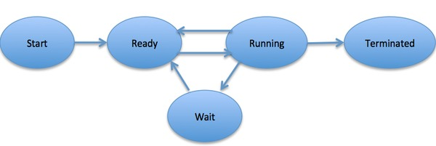

Process Life Cycle

## Q8

1. **Turnaround time** – It is the time interval from the time of submission of a process to the time of the completion of the process. It can also be considered as the sum of the time periods spent waiting to get into memory or ready queue, execution on CPU and executing input/output.
2. **Response time** – It is the elapsed time between an inquiry on a system and the response to that inquiry. Used as a measurement of system performance, response time may refer to service requests in a variety of technologies. Low response times may be critical to successful computing.
3. **Throughput** – It refers to the performance of tasks by a computing service or device over a specific period. It measures the amount of completed work against time consumed and may be used to measure the performance of a processor, memory and/or network communications.

## Q9

Process scheduling is the activity of the process manager that handles the removal of the running process from the CPU and the selection of another process based on a particular strategy. Process scheduling is an essential part of Multiprogramming operating systems. Such operating systems allow more than one process to be loaded into the executable memory at a time and the loaded process shares the CPU using time multiplexing.

|  |  |  |  |
| --- | --- | --- | --- |
| **S.N.** | **Short-Term Scheduler** | **Medium-Term Scheduler** | **Long-Term Scheduler** |
| 1 | It is a CPU scheduler | It is a process swapping scheduler. | It is a job scheduler |
| 2 | Speed is fastest among other two | Speed is in between both short and long-term scheduler. | Speed is lesser than short term scheduler |
| 3 | It has lesser control over the degree of multiprogramming | It reduces the degree of multiprogramming. | It controls the degree of multiprogramming |
| 4 | It is minimal in time sharing system | It is a part of Time sharing systems. | It is almost absent or minimal in time sharing system |
| 5 | It selects those processes which are ready to execute | It can re-introduce the process into memory and execution can be continued. | It selects processes from pool and loads them into memory for execution |

## Q10

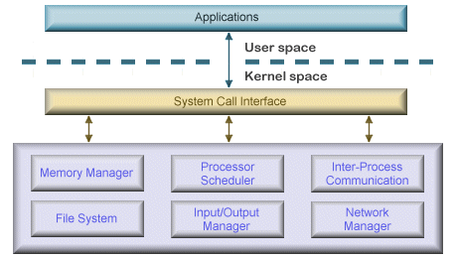

Monolithic OS Architecture

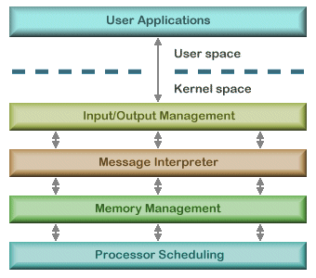

Layered OS Architecture

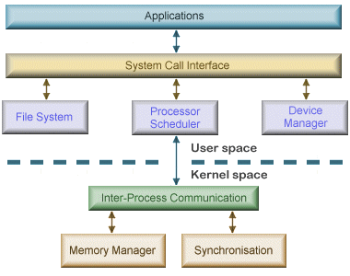

Micro-kernel OS Architecture